HORNELORE LIVE TEST PROTOCOL
Camera / Mic / Affect / Quiet Re-entry
Run in Chrome on the real machine
Test Kent first, then Janice

==================================================
A. BEFORE YOU START
==================================================

1. Close Hornelore tabs.
2. Restart the Hornelore stack if you want a clean run.
3. Open Hornelore fresh in Chrome.
4. Open DevTools:
- press F12
- click Console
5. In the console, clear old messages.
6. Keep DevTools open during testing.
7. Know how to open the Bug Panel in Hornelore.
8. Have a phone ready to take pictures of:
- the main UI
- the Bug Panel
- any unusual popup or message

Important:
- Do not paste the whole console back to me.
- Only save important lines:
- red errors
- repeated warnings
- anything with no-speech
- anything with camera
- anything with consent
- anything clearly wrong

==================================================
B. WHAT TO RECORD DURING EVERY TEST
==================================================

For each test, record these things if they appear:

1. Exact on-screen wording
2. Approximate timing in seconds
3. Whether it happened once or repeatedly
4. What the Bug Panel showed at that moment
5. Any important console line

When I say “Bug Panel values,” write down:
- Camera Active
- Camera Preview
- Facial Consent
- Consent Stored
- STT Engine
- Affect State
- Signal Age
- mic fields if shown

==================================================
C. TEST 1 — KENT FIRST LOAD / CAMERA CONSENT / CAMERA PREVIEW
==================================================

Goal:
Check first-load consent, camera startup, and preview mirror.

Steps:
1. Open Hornelore fresh.
2. Select Kent. Lori
Kent, I'm so glad we're diving into your Early Childhood era. What do you remember about where you grew up in Stanley, North Dakota?
Apr 12 4:00 AM
Lori
Take your time, Kent. Would you like me to summarize back what you shared so far?
Apr 12 4:01 AM
Lori
It feels like you were getting comfortable sharing some thoughts about your childhood in Stanley – no rush at all, take your time if you'd like to continue.
Apr 12 4:03 AM
3. Watch carefully:
- does a facial consent overlay appear? No consent 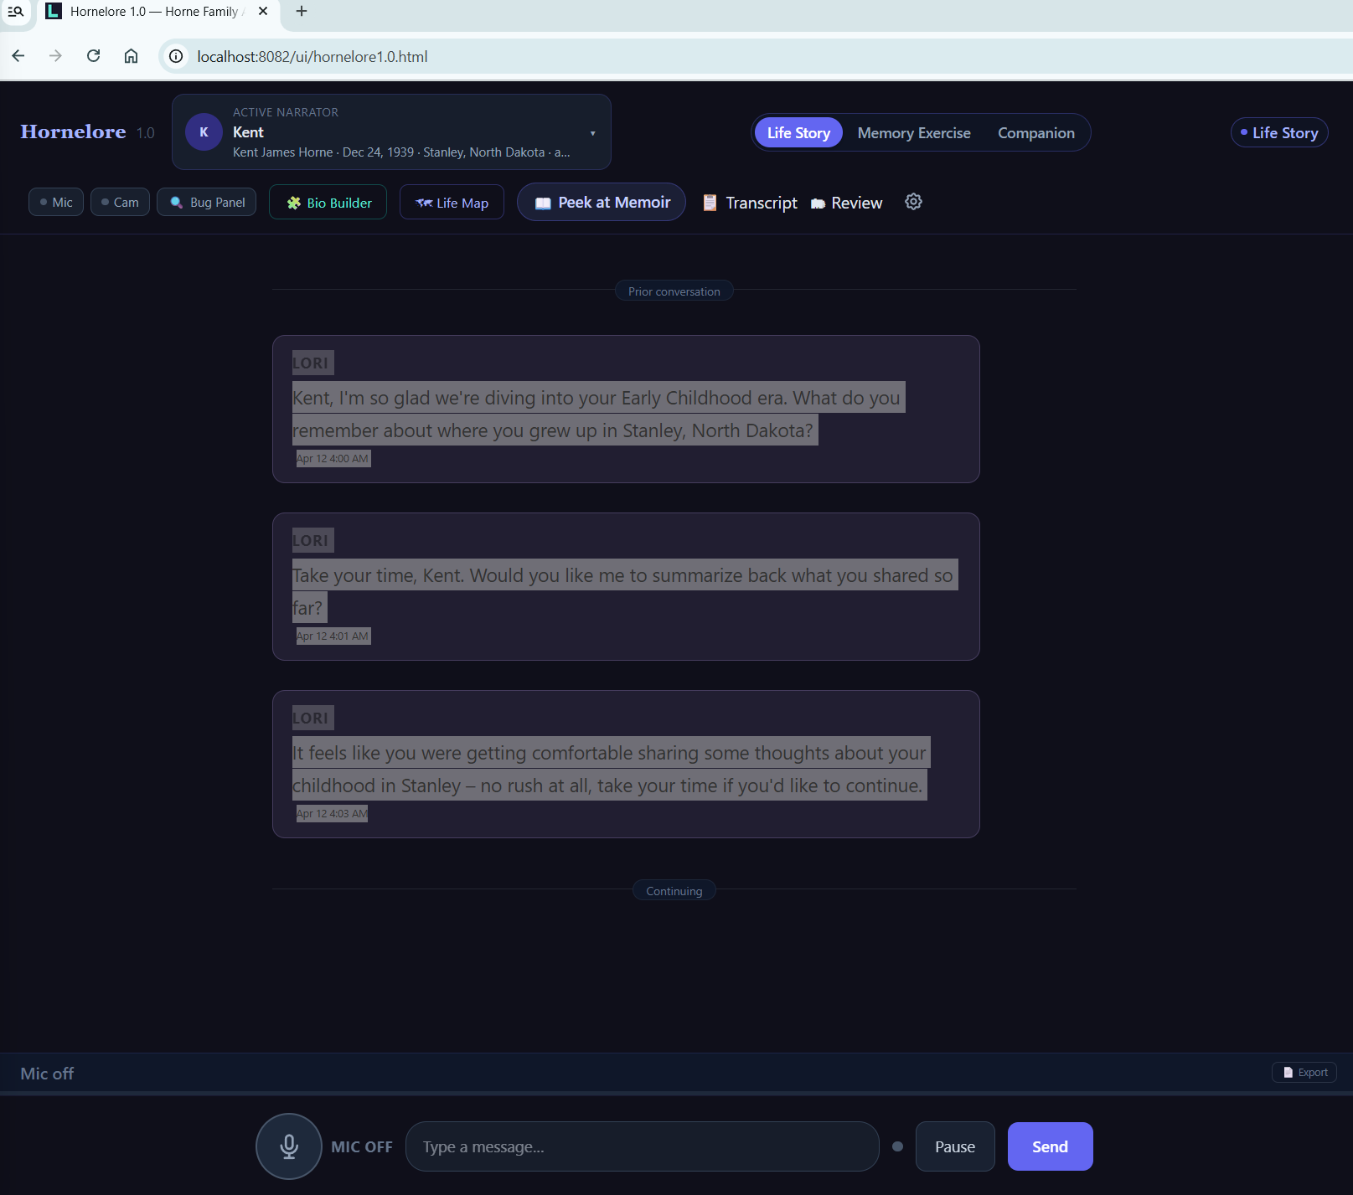
4. If it appears:
- read enough to confirm it is the camera/facial-expression consent
- click the checkbox if required
- click the allow/confirm button
5. Wait for camera startup.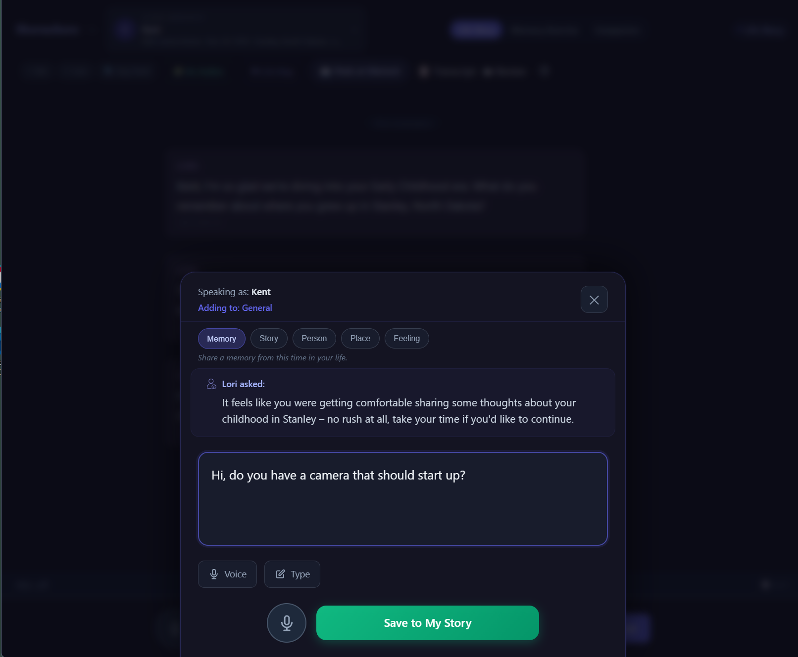
6. Look for the small camera preview mirror. Continuing
Kent
Hi, do you have a camera that should start up?
Lori
Operator_feedback Let's focus on getting our technical issue resolved. I'm happy to help with the camera. Unfortunately, I'm a listening companion and don't have the ability to control devices or access your local hardware. However, I can tell you that my transcription feature does work, and I've been able to capture your previous message correctly. Would you mind repeating your question or trying again? {
"ts": "2026-04-13T18:30:49.521Z",
"narrator": "Kent",
"person_id": "4aa0cc2b-1f27-433a-9152-203bb1f69a55",
"mode": "open",
"pass": "pass2a",
"era": null,
"role": "interviewer",
"llmReady": true,
"mic": {
"recording": false,
"paused": false,
"wo8Paused": false
},
"camera": {
"active": false,
"emotionAware": true,
"previewVisible": false
},
"facialConsent": {
"granted": true,
"stored": true
},
"visualSignals": null,
"ws": {
"connected": true,
"fallback": false
},
"llmParams": {
"temperature": 0.7,
"max_new_tokens": 512
}
}
This image is after I click mic on button 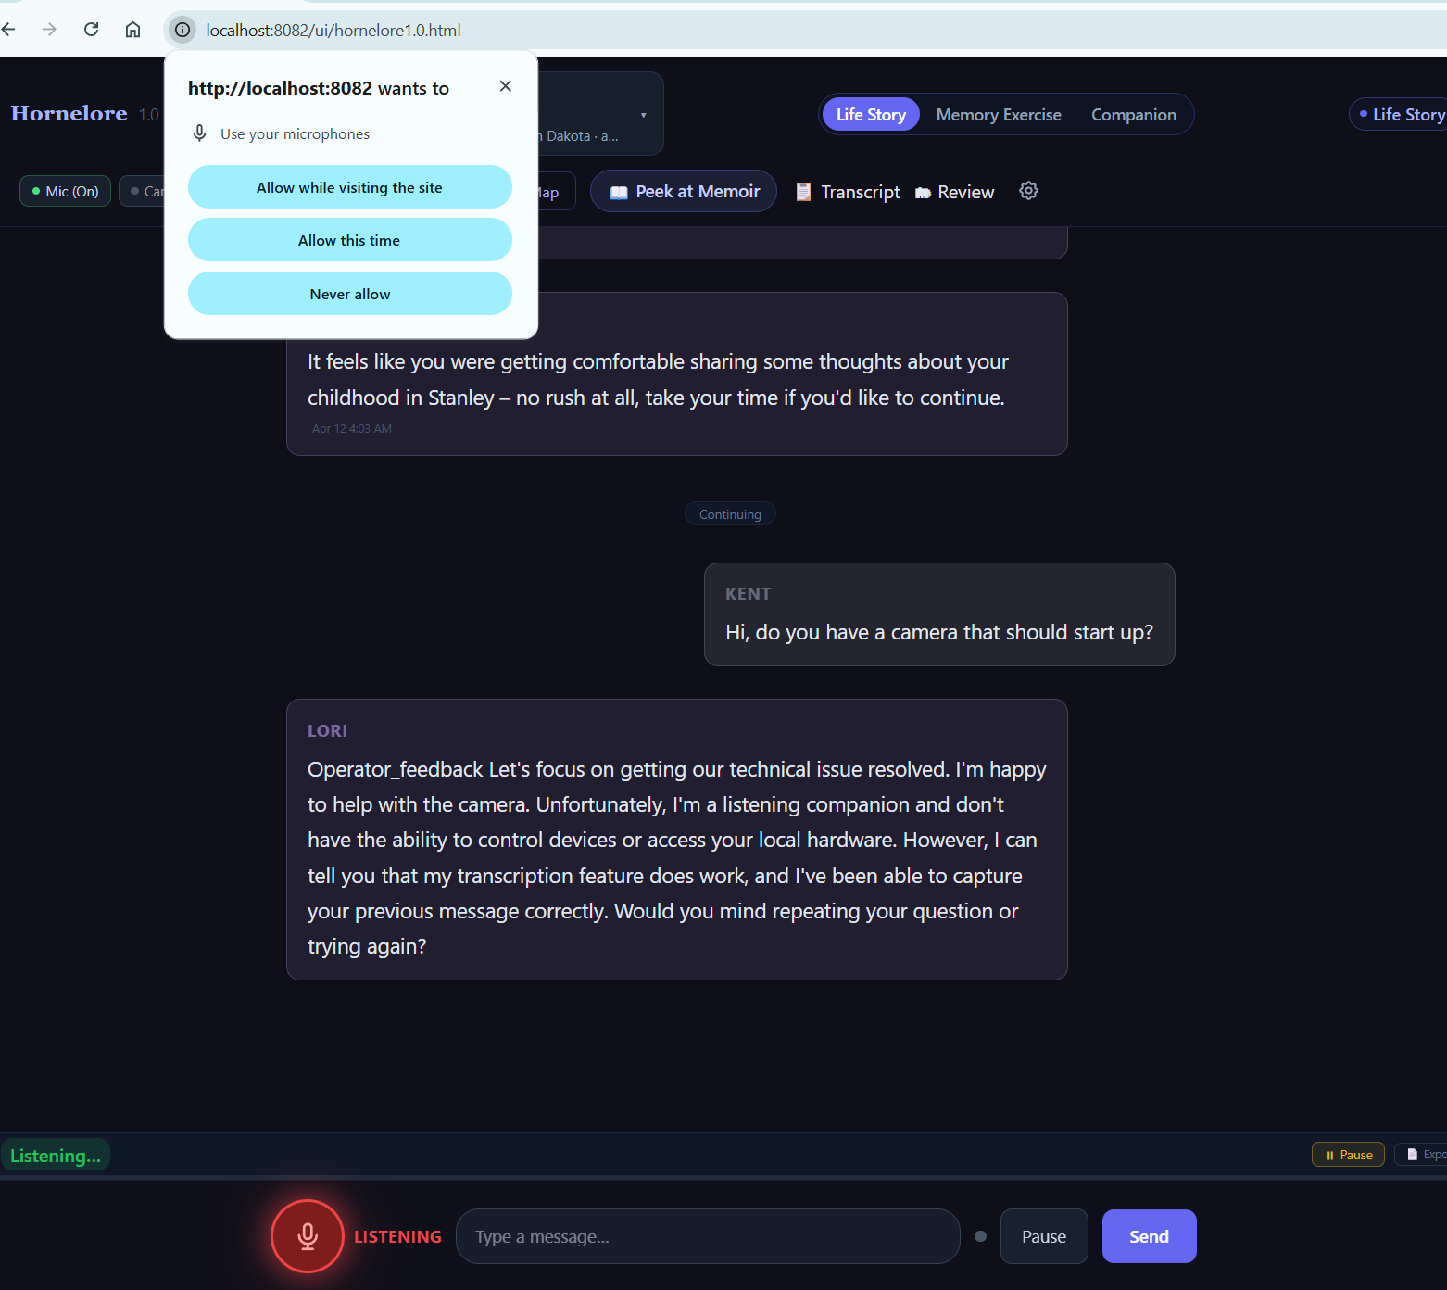 it give the appearance it is listing but it does not take my spoken words and dictate them to be sent

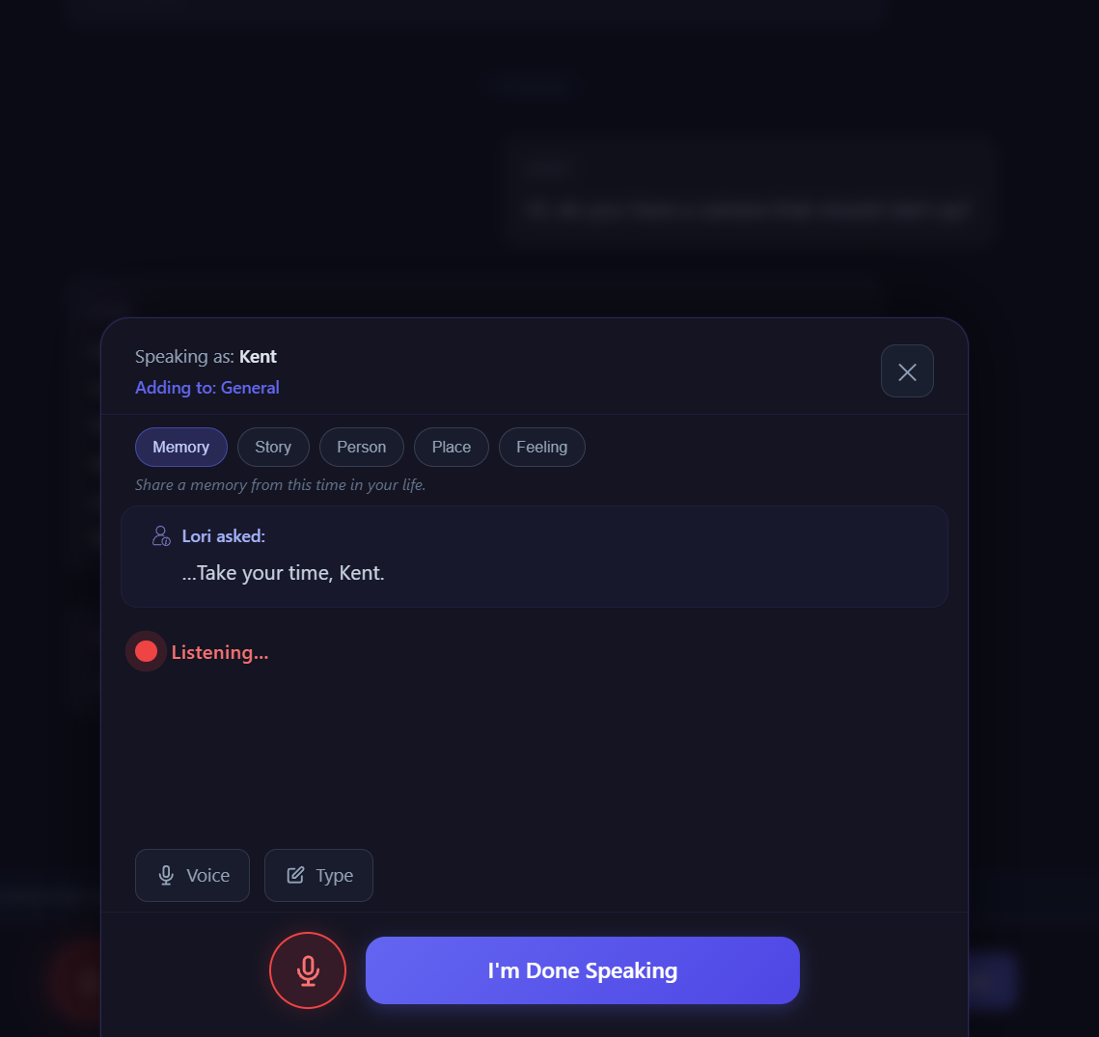

Switch to typing gets a response ori
Kent, shall we pick up where we left off? We were discussing some technical issues earlier. Now, I'd love to get back to hearing more about your life. What do you remember about where you grew up, specifically in Stanley, North Dakota, where you were born in 1939?
Kent
the mic does not pick up my words i have to type to get the message to you
Lori
It seems like the microphone might be having trouble picking up your voice. Let's stick to typing for now. To clarify, I'll just review what we had going. You were sharing about growing up in Stanley, North Dakota, and I wanted to explore that further. Would you like to continue exploring those memories, or is there something else on your mind that you'd like to discuss?
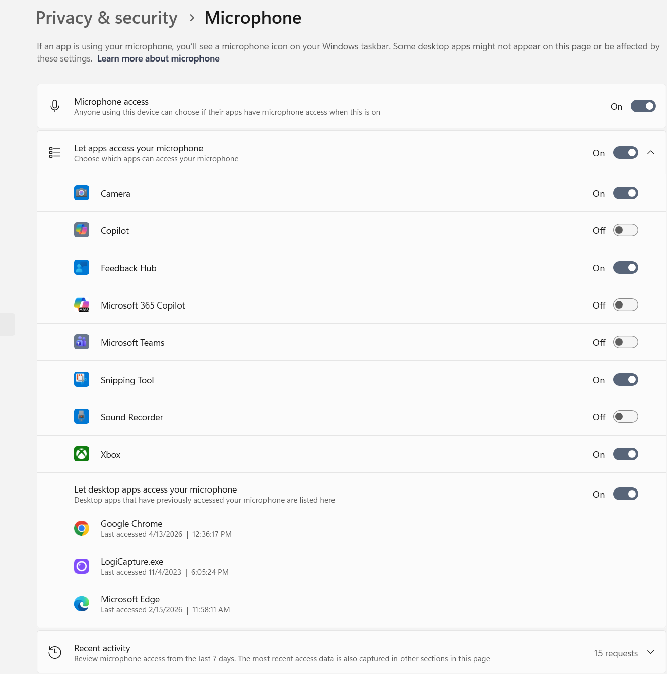
{
"ts": "2026-04-13T18:37:16.108Z",
"narrator": "Kent",
"person_id": "4aa0cc2b-1f27-433a-9152-203bb1f69a55",
"mode": "open",
"pass": "pass2a",
"era": null,
"role": "interviewer",
"llmReady": true,
"mic": {
"recording": false,
"paused": false,
"wo8Paused": false
},
"camera": {
"active": false,
"emotionAware": true,
"previewVisible": false
},
"facialConsent": {
"granted": true,
"stored": true
},
"visualSignals": null,
"ws": {
"connected": true,
"fallback": false
},
"llmParams": {
"temperature": 0.7,
"max_new_tokens": 512
}
}
7. If preview appears:
- confirm whether it shows your live face
- confirm whether it looks mirrored
8. Click the preview close button.
9. Confirm preview hides.
10. Click the reopen control.
11. Confirm preview returns.
12. Open the Bug Panel.
13. Write down the Bug Panel values.
14. Take:
- one picture of the main UI with camera preview
- one picture of the Bug Panel

Record:
- Consent overlay first load: yes/no
- Camera preview auto-appeared: yes/no
- Preview showed live face: yes/no
- Preview looked mirrored: yes/no
- Preview close worked: yes/no
- Preview reopen worked: yes/no
- Exact wording on the consent overlay title if visible
- Any console errors or warnings
Then when I switch to Janice and click the first mic it picks up what I said then I send and lori responds an di click mic again and this as I talk nothing is shown 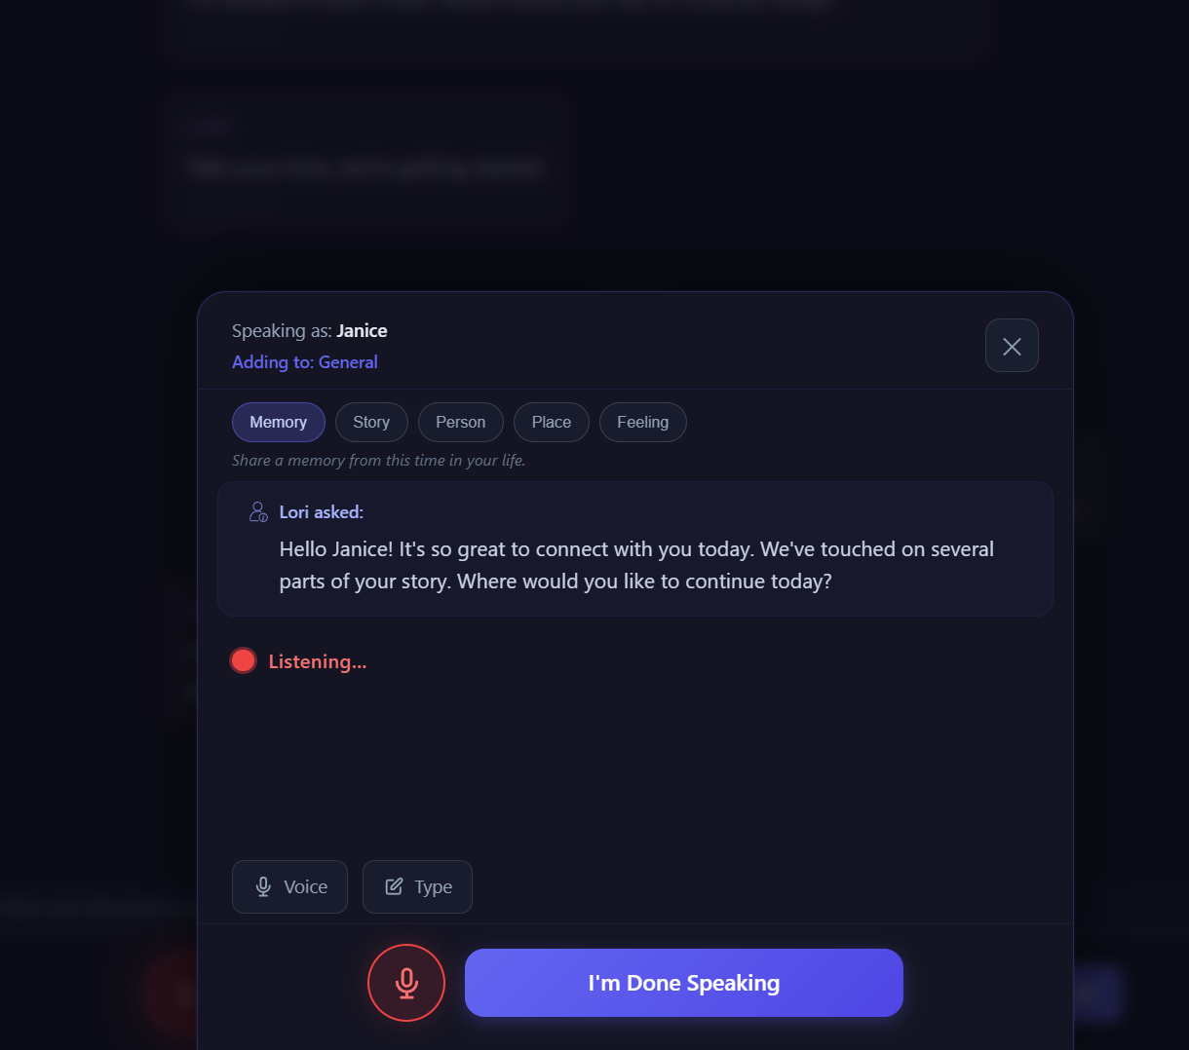
But if I x out at the top I can see what I said and send it to lori with the little button send now 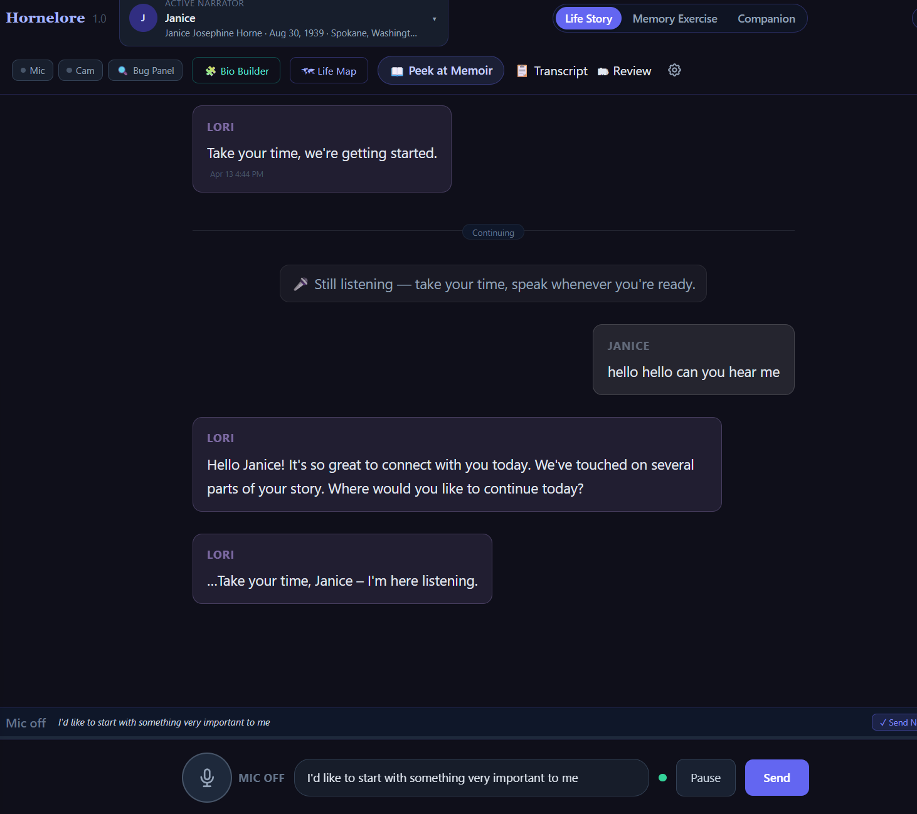
And get a response but no camera
Lori
Hello Janice! It's so great to connect with you today. We've touched on several parts of your story. Where would you like to continue today?
Lori
…Take your time, Janice – I'm here listening.
Janice
I'd like to start with something very important to me
Lori
It feels wonderful that you're eager to share something meaningful with me, Janice. What do you remember about where you were living during your younger years, particularly in the area where you grew up in Spokane, Washington?
Take your time…
Ready
{
"ts": "2026-04-13T18:43:10.839Z",
"narrator": "Janice",
"person_id": "93479171-0b97-4072-bcf0-d44c7f9078ba",
"mode": "open",
"pass": "pass2a",
"era": null,
"role": "interviewer",
"llmReady": true,
"mic": {
"recording": false,
"paused": false,
"wo8Paused": false
},
"camera": {
"active": false,
"emotionAware": true,
"previewVisible": false
},
"facialConsent": {
"granted": true,
"stored": true
},
"visualSignals": null,
"ws": {
"connected": true,
"fallback": false
},
"llmParams": {
"temperature": 0.7,
"max_new_tokens": 512
}
}

D. TEST 2 — KENT RELOAD / CONSENT PERSISTENCE
==================================================
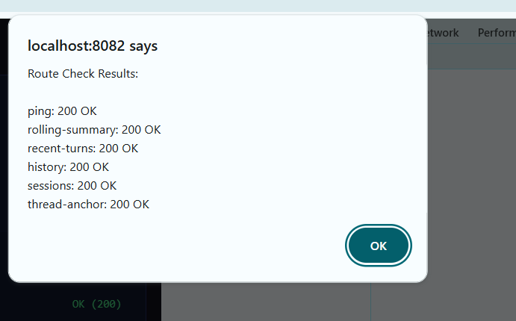

Switched to kent }
hornelore1.0.html:3429 [lv80-turn-debug] {ts: '2026-04-13T18:44:27.869Z', event: 'facts_extracted', facts_extracted_count: 0, facts_posted_count: 0, suppressed: false, …}
hornelore1.0.html:3429 [lv80-turn-debug] {ts: '2026-04-13T18:44:27.870Z', event: 'lori_reply', reply_text: '…Take your time, Janice, I can wait for you to gather your thoughts.', memoir_state_after: 'structured', effective_posture: 'life_story', …}
hornelore1.0.html:3429 [lv80-turn-debug] {ts: '2026-04-13T18:44:27.870Z', event: 'idle_cancel', idle_cancel_reason: 'no_genuine_question'}
app.js:4230 [WO-9] Thread anchor saved: (general) era: (none) keywords: start, something, important, janice, gather
app.js:4318 [WO-9] Rolling summary saved, facts: 0 tone: engaged
hornelore1.0.html:3637 [v9-gate] Opening narrator: 4aa0cc2b-1f27-433a-9152-203bb1f69a55
bio-builder-core.js:344 [bb-debug] restore_ls {ts: '18:44:51.083', pid: '4aa0cc2b', mem: {…}, disk: {…}, section: null}
bio-builder-core.js:195 [bb-core] ✅ Rehydrated 11 QQ candidates for 4aa0cc2b-1f27-433a-9152-203bb1f69a55
bio-builder-core.js:344 [bb-debug] narrator_switch {ts: '18:44:51.084', pid: '4aa0cc2b', mem: {…}, disk: {…}, section: null}
hornelore1.0.html:5209 [memoir] Rendered structured preview: 6 sections from questionnaire/profile data.
app.js:919 [narrator-switch] Hard reset complete — loading new narrator: 4aa0cc2b-1f27-433a-9152-203bb1f69a55
app.js:3023 [WO-2] Session verified for person_id: 4aa0cc2b-1f27-433a-9152-203bb1f69a55
bio-builder-core.js:344 [bb-debug] restore_backend {ts: '18:44:51.149', pid: '4aa0cc2b', mem: {…}, disk: {…}, section: null}
bio-builder-core.js:291 [bb-core] ✅ Questionnaire restored from backend for 4aa0cc2b-1f27-433a-9152-203bb1f69a55
projection-sync.js:572 [projection-sync] ✅ Projection restored from backend for 4aa0cc2b-1f27-433a-9152-203bb1f69a55
bio-builder-graph.js:748 [bb-graph] ✅ Graph restored from backend: 12 persons, 10 relationships for 4aa0cc2b
projection-sync.js:473 [projection-sync] Same narrator reset — persisting and reloading (no wipe)
projection-sync.js:572 [projection-sync] ✅ Projection restored from backend for 4aa0cc2b-1f27-433a-9152-203bb1f69a55
app.js:928 [app] Phase G: narrator state snapshot loaded for 4aa0cc2b-1f27-433a-9152-203bb1f69a55
app.js:949 [WO-13] priorUserTurns for 4aa0cc2b = 0
bio-builder-core.js:344 [bb-debug] restore_ls {ts: '18:44:51.727', pid: '4aa0cc2b', mem: {…}, disk: {…}, section: null}
bio-builder-core.js:195 [bb-core] ✅ Rehydrated 11 QQ candidates for 4aa0cc2b-1f27-433a-9152-203bb1f69a55
bio-builder-core.js:344 [bb-debug] narrator_switch {ts: '18:44:51.728', pid: '4aa0cc2b', mem: {…}, disk: {…}, section: null}
hornelore1.0.html:3677 [v9-gate] Narrator classified as: ready
hornelore1.0.html:3721 [WO-13] lv80SwitchPerson: suppressing legacy resume prompt — no prior user turns
hornelore1.0.html:3747 [v9-gate] Narrator open complete. Status: ready
hornelore1.0.html:6489 [Hornelore] Identity phase set to complete for known narrator: 4aa0cc2b-1f27-433a-9152-203bb1f69a55
app.js:3606 [WO-9] Skipping system message in transcript render: [SYSTEM: The narrator has been quiet for a while. Offer a ge
app.js:3606 [WO-9] Skipping system message in transcript render: [SYSTEM: The narrator claimed the floor but has not submitte
app.js:3640 [WO-8] Loaded 10 transcript events for 4aa0cc2b
app.js:4613 [WO-13] wo8OnNarratorReady: suppressing resume prompt — no prior user turns for 4aa0cc2b
bio-builder-core.js:344 [bb-debug] restore_backend {ts: '18:44:51.761', pid: '4aa0cc2b', mem: {…}, disk: {…}, section: null}
bio-builder-core.js:291 [bb-core] ✅ Questionnaire restored from backend for 4aa0cc2b-1f27-433a-9152-203bb1f69a55
bio-builder-graph.js:748 [bb-graph] ✅ Graph restored from backend: 12 persons, 10 relationships for 4aa0cc2b
hornelore1.0.html:5209 [memoir] Rendered structured preview: 6 sections from questionnaire/profile data.

Nothing here when I speak but underneath and activity in console [memoir] Rendered structured preview: 6 sections from questionnaire/profile data.
focus-canvas.js:50 [FocusCanvas] open() called, trigger: mic
focus-canvas.js:270 [FocusCanvas] _startListening() — window.isRecording: false typeof toggleRecording: function
focus-canvas.js:296 [FocusCanvas] _hookRecognition — polling for window.recognition...
app.js:3421 [STT] recognition started
focus-canvas.js:277 [FocusCanvas] toggleRecording() called — isRecording now: true
focus-canvas.js:301 [FocusCanvas] recognition found after 1 attempts — hooking onresult
app.js:4781 [WO-8] Enhanced voice handlers installed.
app.js:4035 [WO-8] Voice chunk accumulated. Total chunks: 1 Total chars: 11
app.js:4035 [WO-8] Voice chunk accumulated. Total chunks: 2 Total chars: 31
app.js:4035 [WO-8] Voice chunk accumulated. Total chunks: 3 Total chars: 47
app.js:4035 [WO-8] Voice chunk accumulated. Total chunks: 4 Total chars: 63
app.js:4035 [WO-8] Voice chunk accumulated. Total chunks: 5 Total chars: 85
app.js:3395 [STT] no speech detected (count: 16) — waiting…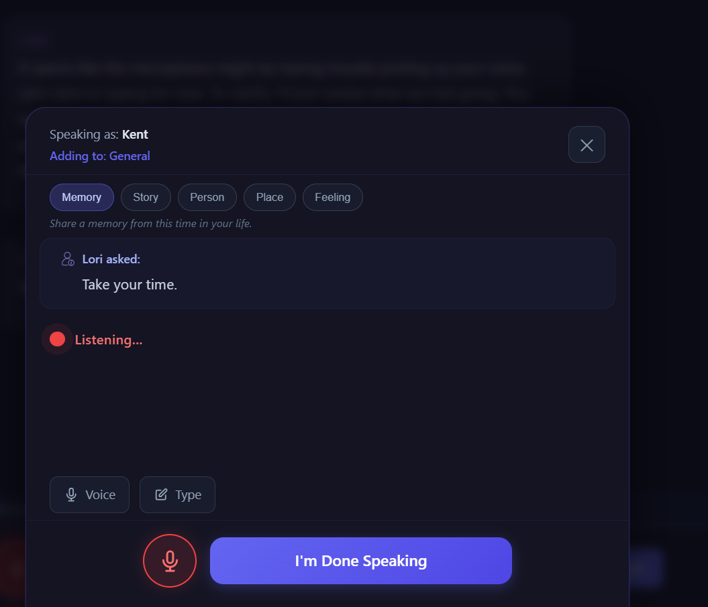

but underneath it is there to send 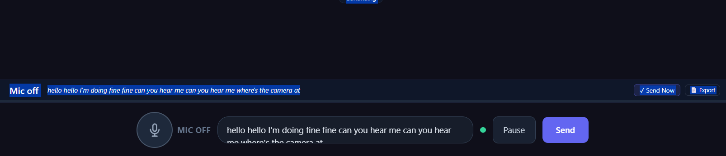

[2026-04-13 18:29:58] USER:
Hi, do you have a camera that should start up?

[2026-04-13 18:30:10] ASSISTANT:
Operator_feedback

Let's focus on getting our technical issue resolved. I'm happy to help with the camera. Unfortunately, I'm a listening companion and don't have the ability to control devices or access your local hardware. However, I can tell you that my transcription feature does work, and I've been able to capture your previous message correctly. Would you mind repeating your question or trying again?

[2026-04-13 18:32:10] USER:
[SYSTEM: The narrator has been quiet for a while. Offer a gentle, warm invitation to continue their life story — one short sentence only. Do not repeat your last question verbatim. FORBIDDEN PHRASES: Never say 'I see you thinking', 'You look confused', 'You seem emotional', 'I notice you paused', 'Are you still there', or any language that observes/labels the narrator's internal state. ALLOWED: 'Take your time', 'I can wait', 'Would you like me to repeat that?', 'No rush at all', or a warm reference to what they were just telling you.]

[2026-04-13 18:32:12] ASSISTANT:
Take your time, Kent.

[2026-04-13 18:34:03] USER:
hello

[2026-04-13 18:34:12] ASSISTANT:
Kent, shall we pick up where we left off? We were discussing some technical issues earlier. Now, I'd love to get back to hearing more about your life. What do you remember about where you grew up, specifically in Stanley, North Dakota, where you were born in 1939?

[2026-04-13 18:34:38] USER:
the mic does not pick up my words i have to type to get the message to you

[2026-04-13 18:34:50] ASSISTANT:
It seems like the microphone might be having trouble picking up your voice. Let's stick to typing for now. To clarify, I'll just review what we had going. You were sharing about growing up in Stanley, North Dakota, and I wanted to explore that further. Would you like to continue exploring those memories, or is there something else on your mind that you'd like to discuss?

Kent
hello hello I'm doing fine fine can you hear me can you hear me where's the camera at
Lori
Kent, I can indeed hear you loud and clear. As for the camera, I'm a text-based interface, so I don't have a visible camera. I'm here to listen and chat with you, and our conversation is being transcribed.
From this message:✕
personal › fullNamedoing fine fine can
ApproveCorrectHoldSource OnlyReject
Open in Shadow Review
{
"ts": "2026-04-13T18:49:55.003Z",
"narrator": "Kent",
"person_id": "4aa0cc2b-1f27-433a-9152-203bb1f69a55",
"mode": "open",
"pass": "pass2a",
"era": null,
"role": "interviewer",
"llmReady": true,
"mic": {
"recording": false,
"paused": false,
"wo8Paused": false
},
"camera": {
"active": false,
"emotionAware": true,
"previewVisible": false
},
"facialConsent": {
"granted": true,
"stored": true
},
"visualSignals": null,
"ws": {
"connected": true,
"fallback": false
},
"llmParams": {
"temperature": 0.7,
"max_new_tokens": 512
}
}

[2026-04-13 18:36:15] USER:
[SYSTEM: The narrator claimed the floor but has not submitted yet. This is normal — they may be thinking or typing. Offer ONE very gentle, non-intrusive presence statement. Say something like: 'Take your time. I'm here when you're ready.' Do NOT ask a new question. Do NOT give a memory nudge. Do NOT comment on the silence. One short sentence maximum.]

}
hornelore1.0.html:3429 [lv80-turn-debug] {ts: '2026-04-13T18:48:58.764Z', event: 'facts_extracted', facts_extracted_count: 0, facts_posted_count: 0, suppressed: false, …}
hornelore1.0.html:3429 [lv80-turn-debug] {ts: '2026-04-13T18:48:58.764Z', event: 'lori_reply', reply_text: 'Kent, I can indeed hear you loud and clear. As for…t with you, and our conversation is being transcr', memoir_state_after: 'structured', effective_posture: 'life_story', …}
hornelore1.0.html:3429 [lv80-turn-debug] {ts: '2026-04-13T18:48:58.765Z', event: 'idle_cancel', idle_cancel_reason: 'no_genuine_question'}
interview.js:1119 [extract][run] deferred extraction firing {turnId: 'turn-1776106131372', source: 'sendUserMessage.freeform', ageMs: 7393}
interview.js:1135 [extract][flush-complete] turnId=turn-1776106131372
app.js:4230 [WO-9] Thread anchor saved: (general) era: (none) keywords: camera, hello, doing, where, indeed
app.js:4318 [WO-9] Rolling summary saved, facts: 2 tone: engaged
interview.js:1205 [extract] Chunk 1/1: 1 items
interview.js:1227 [extract] Backend returned 1 items via rules_fallback
projection-sync.js:101 [projection-sync] ⛔ Protected identity conflict: personal.fullName current=Kent James Horne proposed=doing fine fine can source=backend_extract
projectValue @ projection-sync.js:101
(anonymous) @ interview.js:1316
(anonymous) @ interview.js:1239
Promise.then
_extractAndProjectMultiField @ interview.js:1211
_runDeferredInterviewExtraction @ interview.js:1126
handleWsMessage @ app.js:3014
ws.onmessage @ app.js:2964Understand this warning

[2026-04-13 18:36:17] ASSISTANT:
Take your time.
Goal:
Check whether camera consent persists after reload.

Steps:
1. Reload the page completely.
2. Select Kent again.
3. Watch for the consent overlay.
4. Watch for camera startup.
5. Watch for preview mirror.
6. Open the Bug Panel again.
7. Write down the Bug Panel values.

Record:
- Consent overlay after reload: yes/no
- Camera preview after reload: yes/no
- Facial Consent value:
- Consent Stored value:
- Any console lines mentioning consent or camera

==================================================
E. TEST 3 — KENT MIC VISIBILITY
==================================================

Goal:
Check whether mic state is obvious and readable.

Steps:
1. With Kent loaded, do not start the mic yet.
2. Sit back at normal use distance.
3. Look only at the mic area and nearby status area.
4. Write down exactly what text you see.
5. Turn the mic on.
6. Again, write down exactly what text you see.
7. Then send a short message so Lori replies aloud.
8. While Lori is speaking, look at the same area again.
9. Write down what the state looks like while Lori is speaking.
10. Take one picture of the main UI during:
- mic off
- mic on
- Lori speaking, if possible

Record:
- Mic off label:
- Mic on label:
- Lori speaking state looked like:
- Easy to tell from across room: yes/no
- Any Bug Panel mic values that changed
- Any console errors

==================================================
F. TEST 4 — KENT PAUSE-AND-RESUME SPEECH TEST
==================================================

Goal:
See whether Kent-style pauses still break the turn.

Steps:
1. With Kent loaded, turn mic on.
2. Speak this exactly, slowly:

I was born in Williston North Dakota.
Pause about 5 seconds.
We moved around some when I was young.
Pause about 5 seconds.
My family had strong North Dakota roots.

3. Do not rush the pauses.
4. After finishing, wait a few seconds.
5. If the system needs send/manual finish, do that.
6. Watch the transcript and the UI carefully.
7. Open the Bug Panel right after.
8. Write down the Bug Panel values.
9. Check console for:
- no-speech
- network
- repeated recognition warnings

Record:
- Pause test result: worked / partly worked / failed
- Did transcript stay in one thought or fragment badly?
- Did repeated no-speech errors happen: yes/no
- If yes, what exact line showed?
- Did any “still listening” or gentle waiting prompt appear: yes/no
- Exact wording if it appeared:
- Final transcript quality: good / partial / poor

==================================================
G. TEST 5 — KENT CAMERA-TO-MIC REMINDER
==================================================

Goal:
Check what happens when camera is on but mic is off.

Steps:
1. With Kent loaded and camera on, make sure mic is off.
2. Wait quietly for 10 seconds.
3. Watch the UI for any reminder.
4. If a reminder appears, write down the exact wording.
5. Keep waiting another 20 to 30 seconds.
6. See whether anything smarter happens later.
7. Open the Bug Panel and note values.

Record:
- Reminder appeared: yes/no
- Exact wording:
- Appeared once or repeatedly:
- Anything smarter than a single reminder: yes/no
- Any console messages tied to that moment

==================================================
H. TEST 6 — KENT ELDERLY IDLE TIMER CHECK
==================================================

Goal:
See whether the longer elderly timers are really in effect.

Steps:
1. With Kent loaded, be in a state where Lori is waiting for input.
2. Do not speak.
3. Watch the clock or count seconds.
4. Note when the first soft visual cue appears, if any.
5. Note when an actual check-in prompt appears, if any.
6. Write down the exact wording.
7. Open the Bug Panel after the check-in happens.

Record:
- First soft cue time in seconds:
- First check-in time in seconds:
- Exact wording:
- Felt patient / okay / too fast:
- Any relevant Bug Panel state:

==================================================
I. TEST 7 — JANICE FIRST LOAD / CAMERA / QUIET RE-ENTRY
==================================================

Goal:
Check Janice’s quiet narrator behavior.

Steps:
1. Switch to Janice.
2. Watch whether consent overlay appears.
3. Watch whether preview appears.
4. Open Bug Panel and record values.
5. Then do not speak.
6. Do not turn on the mic unless needed for the scenario.
7. Sit quietly for up to 3 minutes.
8. Watch for any gentle re-entry or prompt from Lori.
9. If a prompt appears:
- write exact wording
- note time in seconds
- judge tone
10. Take:
- one picture of the main UI when Janice is idle
- one Bug Panel picture when the prompt appears, if possible

Record:
- Consent overlay first load for Janice: yes/no
- Camera preview auto-appeared: yes/no
- Quiet re-entry happened: yes/no
- Time before prompt:
- Exact wording:
- Tone felt: gentle / okay / pushy / confusing
- Did it happen once or repeatedly:
- Any console messages

==================================================
J. TEST 8 — JANICE RELOAD / CONSENT PERSISTENCE
==================================================

Goal:
Check Janice repeat-use behavior.

Steps:
1. Reload the page.
2. Select Janice again.
3. Watch for consent overlay.
4. Watch camera startup and preview.
5. Open Bug Panel and write down values.

Record:
- Consent overlay after reload: yes/no
- Camera preview after reload: yes/no
- Facial Consent:
- Consent Stored:
- Any console messages:

==================================================
K. WHAT TO SEND BACK TO ME
==================================================

Send me these two filled blocks.

KENT

Consent overlay first load: yes / no
Consent overlay after reload: yes / no
Camera preview auto-appeared: yes / no
Preview showed live face: yes / no
Preview looked mirrored: yes / no
Preview close worked: yes / no
Preview reopen worked: yes / no

Mic off label:
Mic on label:
Lori speaking state looked like:
Easy to tell from across room: yes / no

Kent pause test result: worked / partly worked / failed
What happened during pause test:
Any no-speech errors: yes / no
If yes, exact wording or console line:
Any gentle waiting message: yes / no
If yes, exact wording:

Camera-to-mic reminder appeared: yes / no
Camera-to-mic reminder wording:
Anything smarter happened later: yes / no

Idle soft cue time:
Idle check-in time:
Idle check-in wording:
Timer felt patient / okay / too fast:

Bug Panel notes:
- Camera Active:
- Camera Preview:
- Facial Consent:
- Consent Stored:
- STT Engine:
- Affect State:
- Signal Age:
- Mic fields:

Console notes:
- red errors:
- repeated warnings:
- anything important:

JANICE

Consent overlay first load: yes / no
Consent overlay after reload: yes / no
Camera preview auto-appeared: yes / no

Quiet re-entry happened: yes / no
Time before prompt:
Exact wording:
Tone felt: gentle / okay / pushy / confusing
Happened once or repeatedly:

Bug Panel notes:
- Camera Active:
- Camera Preview:
- Facial Consent:
- Consent Stored:
- STT Engine:
- Affect State:
- Signal Age:
- Mic fields:

Console notes:
- red errors:
- repeated warnings:
- anything important:

Pictures attached:
- yes / no

If yes, attach:
1. Kent main UI
2. Kent Bug Panel
3. Janice main UI
4. Janice Bug Panel

